**The Battle of Neighborhoods**

**- FINAL REPORT – June 2020**

**Author: Francesco Iervolino**

1. **Introduction**

This project aims to utilize all Data Science Concepts learned in the IBM Data Science Professional Course. We define a Business Problem, the data that will be utilized, and using that data, we can analyze it using Machine Learning tools.

This final project explores the best locations for Chinese restaurants throughout the city of New York. New York is a major metropolitan area with more than 8.4 million (Quick Facts, 2018) people living within city limits.

Chinese immigration in the United States has a long and fraught history. Throughout the first half of the 19th century, Chinese manual laborers (predominately men) migrated to the West Coast, where they found employment in agriculture, mining, railroad construction, and other low-skilled jobs. The number of immigrants from China residing in the United States nearly doubled from 1980 to 1990, and again by 2000. Since then the population continued growing but at a slower pace.

The Chinese American population of the New York City metropolitan area was an estimated 893,697 as of 2017. New York City itself contains by far the highest ethnic Chinese population of any individual city outside Asia, estimated at 628,763 as of 2017 [[ [United States Census Bureau](https://en.wikipedia.org/wiki/United_States_Census_Bureau).]](https://en.wikipedia.org/wiki/Chinese_people_in_New_York_City#cite_note-3).

This report explores which neighborhoods and boroughs of New York City have the most as well as the best Chinese restaurants.

1. **Problem Statement**

* What is / are the best location(s) for Chinese cuisine in New York City?
* In what Neighborhood and/or borough should I open a Chinese restaurant to have the best chance of being successful?
* Where would I go in New York City to have the best Chinese food?

1. **Data**

In order to answer the above questions, data on New York City neighborhoods, boroughs to include boundaries, latitude, longitude, restaurants, and restaurant ratings and tips are required.

For this project the Foursquare API will be used. All data related to locations and quality of Chinese restaurants will be obtained via the FourSquare API

New York City data containing the neighborhoods and boroughs, latitudes, and longitudes will be obtained from the data source: <https://cocl.us/new_york_dataset>

Geospatial data of the New York to get a better understanding of the neighborhoods in it and their corresponding locations in the Folium map would make certain things clear for the Project. This will be achieved using the acquired data and visualize the same using Choropleth maps. Data source: <https://data.cityofnewyork.us/City-Government/Borough-Boundaries/tqmj-j8zm>

1. **Methodology**

The data that will be required will be a combination of CSV files that have been prepared for the purposes of the analysis from multiple sources.

Data will be collected from  <https://cocl.us/new_york_dataset> and cleaned and processed into a dataframe.

FourSquare will be used to locate all venues and then filtered by Chinese restaurant. Ratings, tips, and likes by users will be counted and added to the dataframe.

Data will be sorted based on rankings and will be visually assessed using graphing from various Python libraries.

1. **Results**

* Manhattan has the least number of neighborhoods per borough.

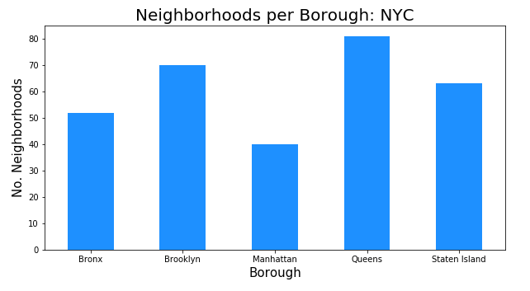

* However, Manhattan has the same number of restaurants of Brooklyn. Queens has the highest number of Chinese restaurants.

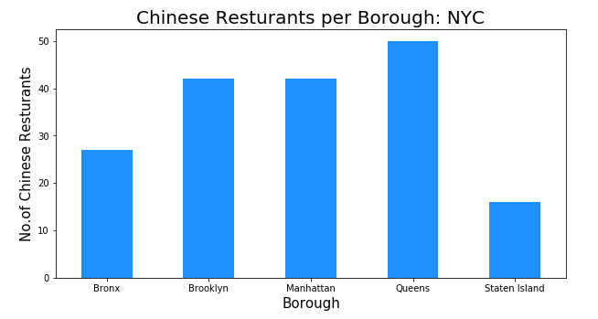

* The top 6 Neighborhood of NYC for number of Chinese restaurants. Chinatown (Manhattan) holds the highest number: 9

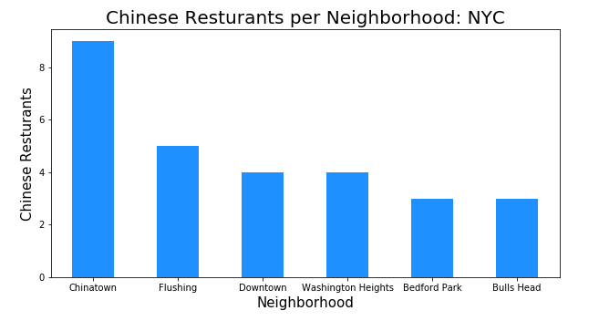

* Manhattan has also the highest average rating (>7.0), and Brooklyn is at second place with an average rating < 5.0

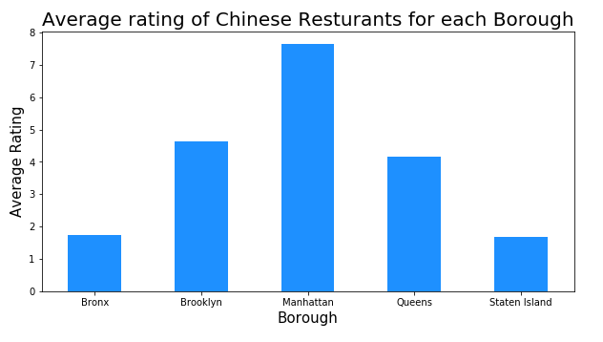

* Manhattan is clearly the densest borough regarding Chinese restaurants making competition high.

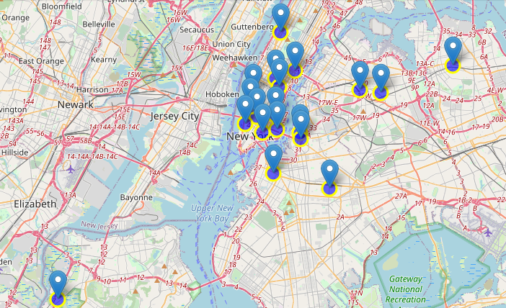

* Boroughs like Brooklyn and Queens provide less competition based on Chinese restaurant density even if the average ratings are lower than 5.0.

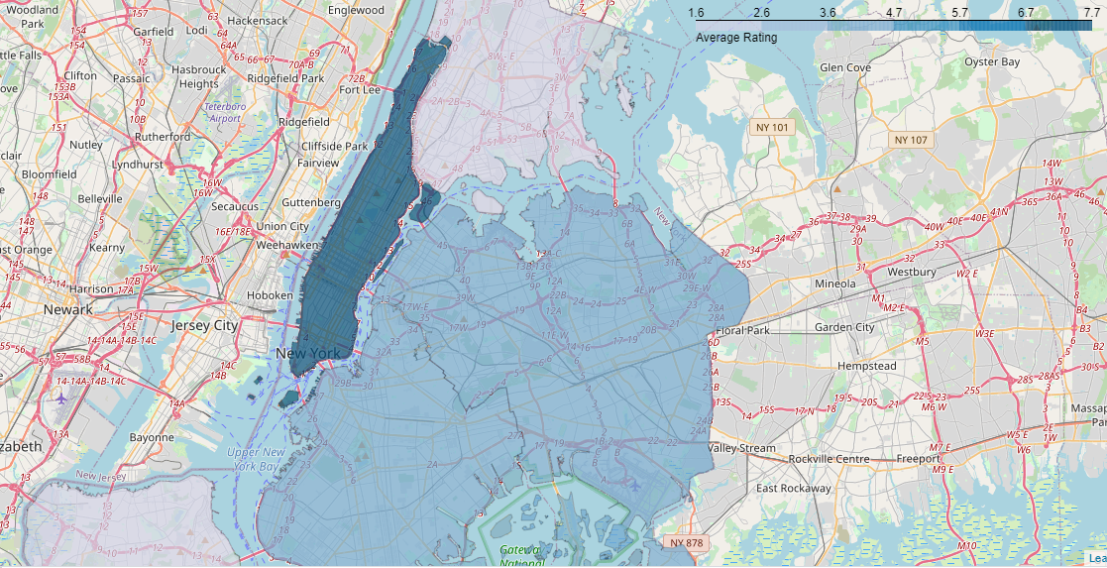

# Conclusion & Discussion

Despite Manhattan having the least number of neighborhoods in all five boroughs, it is clearly the densest borough regarding Chinese restaurants. This makes the competition high because it has the best rated Chinese restaurants on average too.

If the intention is to open a high-quality Chinese restaurant in NYC and in an area close to Manhattan, then I would consider opening it in Brooklyn and/or Queens. Brooklyn and Queens have multiple neighborhoods and Queens has the highest number of Chinese restaurants. However, the average ratings of these restaurants do not exceed 5.0 of a scale of 1.0 to 10.0. This would make the competition easier than in a high rated borough like Manhattan.

Personally, now I would go to Chelsea in Manhattan for the best Chinese food based on 1488 likes and I would definitely try the Chinese restaurant in Lower East Side with the highest rating.

As a final note, all of the above analysis is depended on the adequacy and accuracy of FourSquare data.

# References

*Quick Facts*. (2018, 07 01). Retrieved from census.gov: <https://www1.nyc.gov/site/planning/planning-level/nyc-population/current-future-populations.page>

*MPI (Migration Policy Institute):* <https://www.migrationpolicy.org/article/chinese-immigrants-united-states?gclid=CjwKCAjwztL2BRATEiwAvnALcvncK_kgEAI599thKdvfMJtTn0MXysfnG8HMEYpf7H95GcYuCUZyrxoCqMgQAvD_BwE>